SSH login attempts

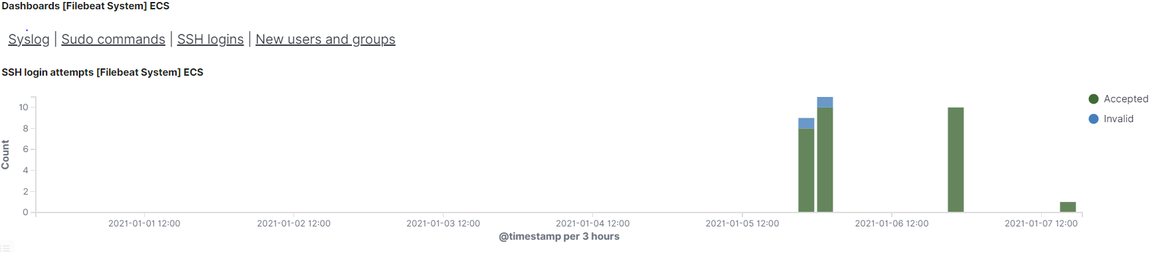

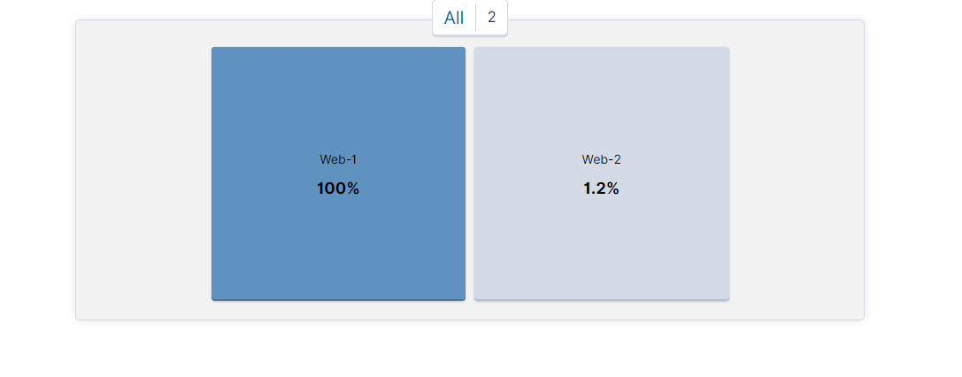

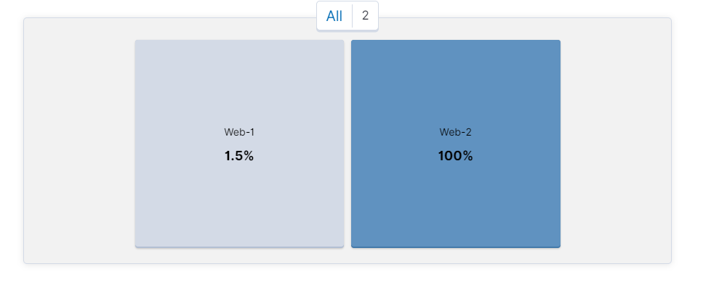

For loop

Which of the VM metrics were affected the most from this traffic? Load and network traffic

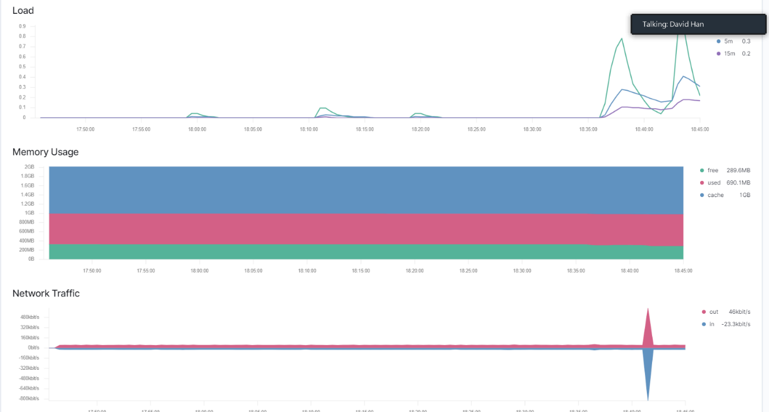

Command to delete all files: rm \*